Personal Portfolio Website-Hema Chandra

Project Title:
Personal Portfolio Website A responsive website to showcase personal projects, skills and contact information.

Overview:
This is a responsive personal portfolio website built using HTML, CSS, and JavaScript. It showcases my professional background, skills, projects, and contact information in a clean, modern, and interactive layout.

Core Modules:
  - Introduction (Home)
  - About Me Section
  - Projects Portfolio
  - Skills & Technologies
  - Education Details
  - Contact Form / Details
  - Downloadable Resume
  - Social Media Links

Tech Stack
- HTML5 – Page structure and content.
- CSS3 – Styling and layout using Flexbox, Grid, and animations.
- JavaScript – For interactivity and animations.
- Netlify – For hosting the live site.

Technology - Purpose

HTML5 Structure of the website (headings, sections, content)
CSS3 Styling the website (fonts, colors, layout, responsiveness)
JavaScript Basic interactivity (scroll effects, animations, toggles)
Git & GitHub Version control and code hosting
Hosting Platform GitHub Pages / Netlify for deploying the website

Features
- Responsive design for desktop, tablet, and mobile
- Smooth scroll and animated transitions
- Hamburger menu for mobile view
- Project showcase section with interactive cards
- Contact form (can be integrated with backend)
- Downloadable resume button
- Social media links

Folder Structure
├── index.html
├── style.css
├── script.js
├── images/
│ └── (all your image files)
├── resume.pdf
└── README.md

Sections Explained
- Hero Section:
My name, title, and a quick introduction with a background image or colour gradient.
- About Me:
A short description of who I am, passion, and goals.
- Skills:
Visual representation of technical and soft skills.
- Education:
My education details of 10th class, Intermediate and my graduation.
- Projects:
Cards or tiles showing my work with links to GitHub and about the projects.
- Contact:
A simple form and my email/social profiles and this data is stored in a Google Sheet using Apps Script!
- Footer:
Rounds out the website with proper credits or copyright.
- Message Feedback
Shows feedback after form submission (success message).
- Social Media Icons
Icons are enlarged for emphasis and change color on hover.

Frontend Development Skills
HTML
- Structuring web pages using semantic HTML tags (<header>, <section>, <footer>, etc.)
- Forms, links, buttons, and inputs
- Embedding images, icons, and external fonts
CSS
- Styling layouts (colors, padding, margins, font styles)
- Responsive design using:
- Media queries for mobile/tablet view
- Flexbox and/or Grid layouts
- Animations/transitions (hover effects, fade-in, slide, etc.)
- Using Google Fonts or custom fonts
JavaScript
- DOM manipulation (e.g., toggling mobile menu, form submission handler)
- Adding interactivity like:
- Hamburger menu
- Contact form validation
- Dynamic "Thank You" message
- Basic event handling (click, submit, etc.

Project Workflow – Step-by-Step
- Plan Portfolio Sections
Decide what sections to include – typically: Home, About, Skills, Projects, Contact.
- Create HTML Structure
Build the HTML for each section: hero, about, skills, projects, contact form, footer, etc.
- Style with CSS
Use modern CSS (Flexbox/Grid, gradients, transitions) to style each section responsively.

- Add Animations (Optional)
Use keyframes, : hover effects, or JavaScript libraries like AOS/GSAP to animate elements.
- Contact Form UI
Design the form using <input>, <textarea>, and a submit <button> inside the contact section.
- Connect to Google Sheets
Use a deployed Google Apps Script that receives form data and appends it to a Sheet

- JavaScript Validation
Validate phone (10 digits) and email (regex) before submitting the form.

- Submit Form with Fetch API
On successful validation, submit the form data to the Google Apps Script endpoint via fetch ().

- Display Thank You Message
If submission is successful, hide the form and show a success <p> message dynamically.

- Deploy on Netlify
Push code to GitHub and deploy your site using Netlify. Free hosting, custom domain, HTTPS included.

- Test Responsiveness
Use DevTools to test layout across desktop, tablet, and mobile. Fix breakpoints if needed.
12. Final Touches
Add favicon, social links, GitHub buttons, and smooth scroll features.
13.Write Documentation
Add README.md with project description, features, technologies used, live demo link, and usage instructions.

Deployment & Hosting

Netlify Hosting
- How to deploy a static site using Netlify
- Using index.html, style.css, and JavaScript files in a proper folder structure
- Drag & drop deployment or connecting via GitHub

Debugging & Testing
- Fixing layout issues across devices (mobile vs desktop)
- Solving JavaScript errors (like form submission or menu toggle)
- Inspecting elements in browser dev tools

Screenshot
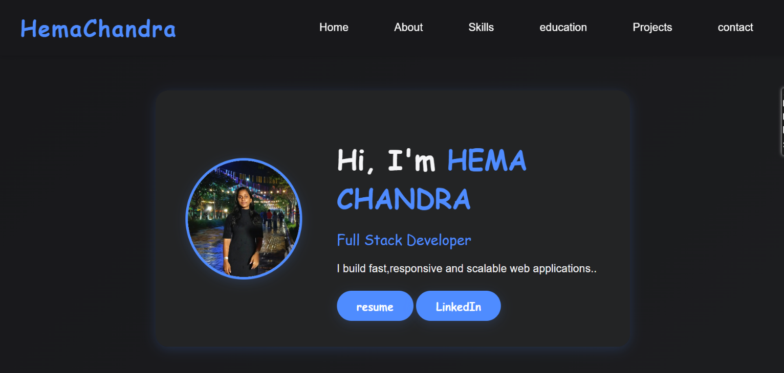
- Desktop

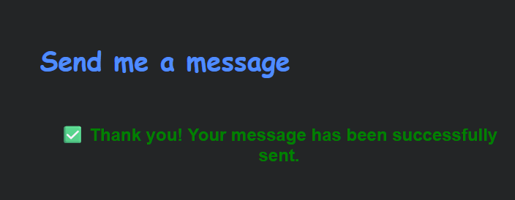
- Thank message after submitting the form in contact section

- Mobile View
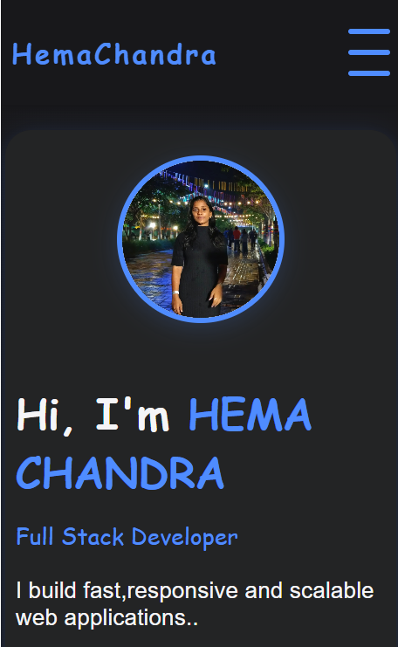
Contact
- Email: yhemareddy07@gmail.com
- LinkedIn: link
- GitHub: link

License

This project is open source and available under the MIT License.

